**Excel Assignment 5**

1. **What is a ribbon in Excel?**

Microsoft Excel ribbon is the row of tabs and icons at the top of the Excel window that allows you to quickly find, understand and use commands for completing a certain task.

1. **What is the order of operations used for evaluating formulas in excel?**

Excel solves formulas in the following order:

* Parentheses
* Reference operators
* Exponents
* Negation
* Percent
* Multiplication and Division
* Addition and Subtraction
* Concatenation
* Logical operators

1. **Reverse the string in the excel column and check whether the string is palindrome or not in the next column for each value.**

|  |  |  |
| --- | --- | --- |
| **Word** | **Reverse Word** | **Is Palindrome** |
| **EYE** | **EYE** | **TRUE** |
| **EAR** | **RAE** | **FALSE** |

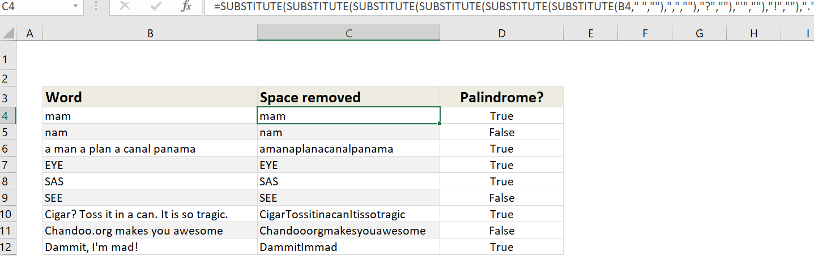

1. **Is it possible to protect value from being copied from the cell? If yes, then how to implement it.**

Yes, it is possible. In order to protect your worksheet from getting copied, you need to go into Menu bar >Review > Protect sheet > Password. By entering password, you can secure your worksheet from getting copied by others.

1. **What is the use of Name Box in MS-Excel?**

In Excel, the Name Box refers to an input box directly to the left of the formula bar. The Name Box normally displays the address of the "active cell" on the worksheet. You can also use the name box to quickly create a named range. Another use for the Name Box is to navigate quickly to any range in a worksheet.